## CS 457/557 -- Winter Quarter 2018

## Project #6

### Geometry Shaders for Quantizing 3D Geometry: The Lego™ Project

Stewart Rodger

rodgers@oregonstate.edu

03/14/2018

The vertex and fragment shaders are bare bones to calculate the lighting, color and the normal.

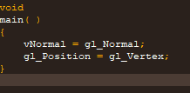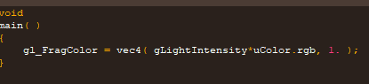

Everything else is in the geometry shader:

Working off the sphere subdivision handout, we set the variables for the corner points and the corner normals of the original triangle:

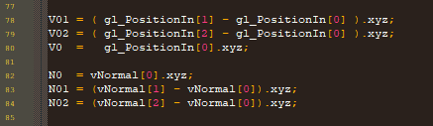

Another critical change to the sphere subdivision shader is the addition of the normal to the ProduceVertex function.

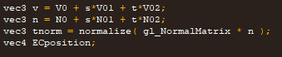

Model and eye coordinates are handled by a simple if/else with one quantizing the vertex and the other quantizing the ECposition.

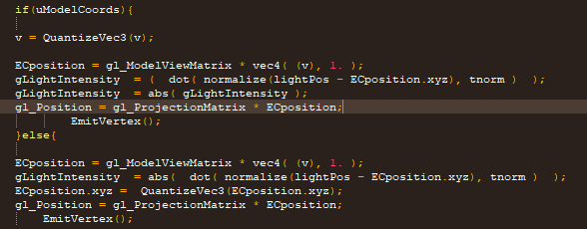

The finished product:



Link to the Kaltura demonstration:

https://media.oregonstate.edu/media/t/0_a3ooic8y